**ENVIRONMENTAL MONITORING USING**

**INTERNET OF THINGS(IoT)**

**TEAM LEADER.**

**712221121005-**

**GANISHKA.R**

**Phase 3 Document Submission**

**Project Title:** Environmental Monitoring

**Phase 3:** Development Part 1

**Topic:** Start building Environmental Monitoring by loading and preprocessing the dataset

**Introduction**

There are several factors contribute to the sustainable growth of the entire world, including

education, agriculture, industry and more. However, one of the most crucial factors is the environment.

Health and hygiene are key components of a healthy environment, which leads to sustainable societies.

Therefore, it is imperative that health and hygiene is monitored to ensure that the citizens of any nation

can lead a healthy life. The environment is a vital component of human health, and proper planning,

management and response to all types of disasters can significantly contribute to the well-being of

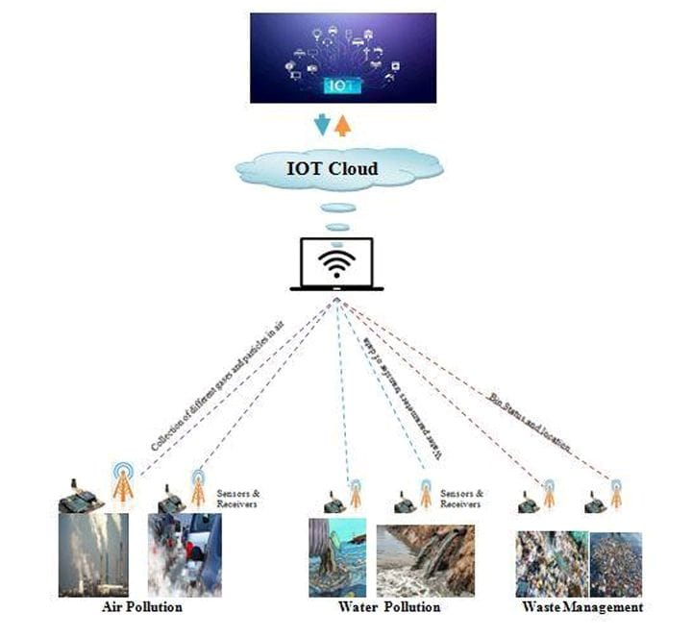

human society.Environment monitoring (EM) techniques have been refined by the use of advanced

environmental monitoring (AEM) methods, which allow more precise monitoring of factors impacting

the environment.Wireless sensor networks (WSNs), which use modern sensors and artificial intelligence

(AI) to monitor and control the environment, are becoming increasingly popular.The Internet of Things

(IoT) is the communications network of everyday objects containing sensors, actuators and connectivity

to external devices. It enables remote monitoring and control of physical objects at a distance and in real

time.As a result of the presence of Internet of Things, artificial intelligence and wireless sensors, modern

methods of monitoring the environment are known as advanced environmental monitoring (AEM)

systems. "Internet of Things" (IoT) refers to a concept in which machines and other physical objects are

connected to the Internet [1]. IoT allows them to exchange data, communicate with each other, and

gather information from external sources [2]. The International Data Corporation estimates that by 2026,

there will be more than a $61 billion market for connected devices, including industrial machines,

vehicles, and homes on the Internet. To transform our society and industry, Internet of Things (IoT) is a

new paradigm that has recently becoming a key consideration in a variety of markets [3]. Various

devices equipped with sensing, identification, processing, communication, and actuation capabilities can

seamlessly be integrated [4]. The long-term health of the global economy depends on several factors,

including economic development, quality education, agricultural production, and other areas. However,

it is essential to remember that environmental conditions also play a role in determining sustainable

growth [5].

**Loading and Preprocessing Dataset:-**

1. **Data Collection**: Environmental monitoring data can be collected from various sources, such as sensors, weather stations, remote sensing devices, or databases. Ensure you have access to the raw data in a suitable format, which could be CSV, Excel, JSON, or other common formats.
2. **Data Inspection**: Before loading the data, it's crucial to inspect it to understand its structure and content. Look for missing values, outliers, and inconsistencies. This step will help you make decisions about data preprocessing.
3. **Data Loading**: Use a programming language such as Python or a data analysis tool like R to load the data into your working environment. For example, in Python, you can use libraries like Pandas to read data from CSV files or other formats.
4. **Data Cleaning**:
   * **Handling Missing Values**: Environmental datasets often have missing data. Decide how to handle these missing values, either by imputing them or removing the affected rows or columns.
   * **Outlier Detection and Treatment**: Identify and handle outliers, which can significantly affect the analysis. You may decide to remove them, transform the data, or use robust statistical methods.
5. **Data Transformation**:
   * **Feature Engineering**: Create new features from the existing data if it helps in analysis. For example, derive daily averages from hourly data.
   * **Normalization/Scaling**: Normalize or scale the data if you plan to use machine learning algorithms that are sensitive to feature scales.
   * **Data Aggregation**: If your data is collected at high frequency, you might want to aggregate it to a lower frequency (e.g., daily or monthly averages) for analysis.
6. **Data Visualization**: Create visualizations of the data to gain insights and better understand patterns and trends. Matplotlib and Seaborn in Python are common libraries for this purpose.
7. **Exploratory Data Analysis (EDA)**: Conduct EDA to identify relationships, correlations, and patterns in the data. This step often involves statistical analysis and hypothesis testing.
8. **Data Splitting**: If you plan to build models, split the dataset into training, validation, and test sets. Cross-validation is also a useful technique for model evaluation.
9. **Data Preprocessing for Machine Learning**:
   * **Encoding Categorical Variables**: If your dataset contains categorical variables, encode them into numerical format, e.g., one-hot encoding.
   * **Feature Scaling**: Standardize or normalize features, especially if you plan to use machine learning algorithms.
   * **Dimensionality Reduction**: Consider techniques like PCA to reduce the dimensionality of the data if it's too high.
10. **Saving Processed Data**: Save the preprocessed dataset for further analysis and modeling to avoid redoing these steps every time you work on the project.

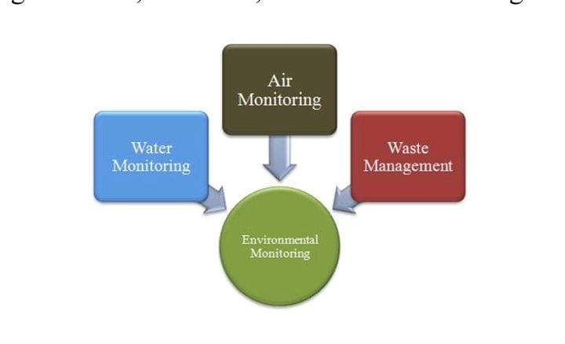

Smartly Environmental Monitoring

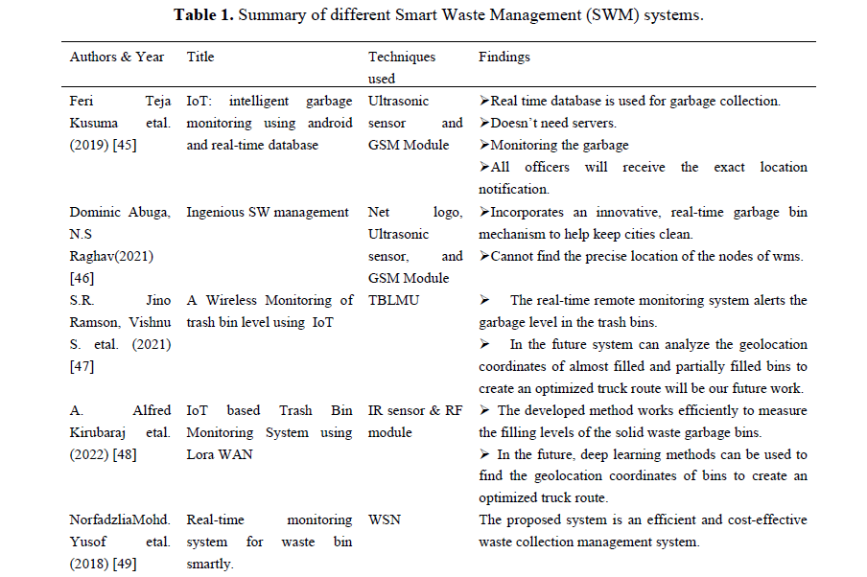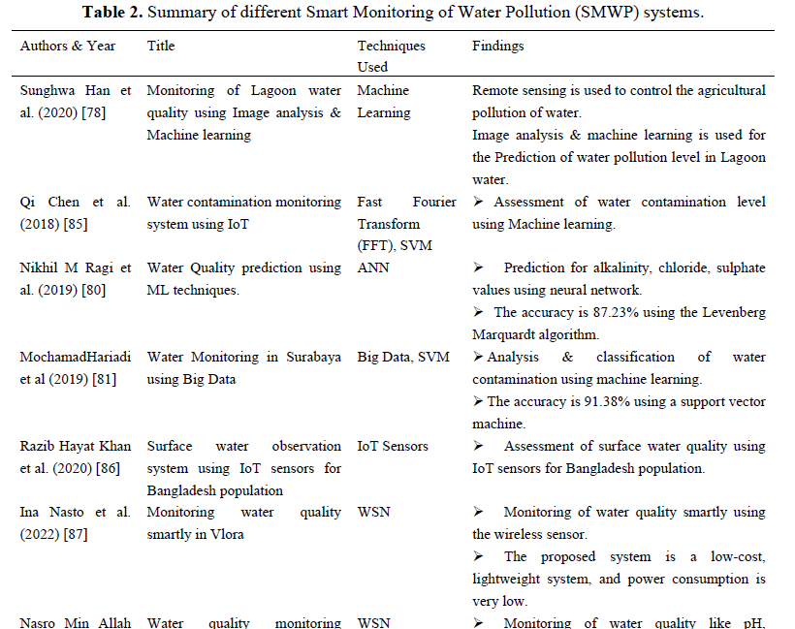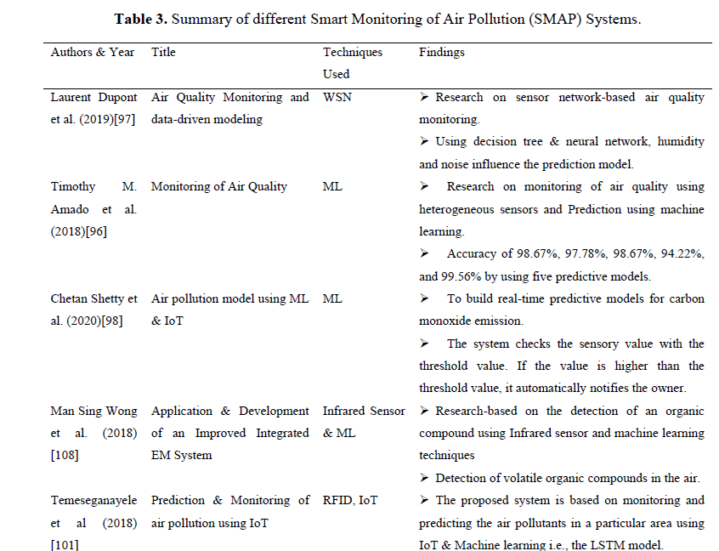

**Discussion, analysis, and recommendation:-**

Analysis and recommendations based on an extensive literature review are discussed in this section

on the available automated environment monitoring systems, including the following: Air quality

assessment, contaminated water monitoring, and waste management. The contributions focus on several

Automated Environment Monitoring methods for air-quality assessment, contaminated water monitoring,

and waste management. The systems were also evaluated based on the techniques used. The following

are the significant discussion points to consider:

1) This research contain various grounds mainly on SMAP, SMWP, and SWM can lead to a good

design of an intelligent environment system which in future might also help the economy's growth

through a safe and clean environment.

2) A few types of sensors are used along with sensory data, machine learning approaches, and IoT

appliances. The current study mainly focuses on the influence of existing studies on contaminated water

monitoring, the application of SEM, air quality assessment, and intelligent waste management systems.

3) Many researchers in most SEM methods currently use SMAP, SMWP, and SWM CNN-based

deep learning methods.

4) In most applications, the sensory data vary. The regions of interest and data type don’t match for

different research work.

5) Classification or Prediction can be made using these methods like water is distinguish as

polluted or clean water, just like how air quality can be predicted.

There are no common challenges found in the above studies reported. Also, the purposes and

techniques differ a lot from each other. Here, the few challenges observed are as follows:

1) Data from heterogeneous sensors must be transformed and analyzed to ensure the

interoperability of that data.

2) Noisy data can be a problem for statistical analysis. One common type of noise, sensor noise,

can occur when measurements are fed into a system by a sensor.

3) The machine learning methods predominantly work training the data and classification are SVM

& Neural networks.

4) Fuzzy set theory-based and deep learning techniques solve a few analysis problems. However,

there are limitations associated with the big data involved or the high computational complexity.

5) No robust machine-learning model exists to address the challenges of environmental monitoring

and control.

Quantitative & qualitative research has been carried out in Environmental Monitoring using IoT &

Machine learning and IoT & WSN. Table 4 shows a summary of this research using the above methods.

Trends in the scholarly literature have been assessed through a search of the Scopus database

during a thirteen-year examination period (2010–2022). Extrapolations using these publication statistics

were conducted to predict trends in SEM technology that may be useful for engineers and manufacturers

of SEM systems.

An interesting finding is that analysis using advanced machine-learning methods lags behind

research that does not use machine learning.

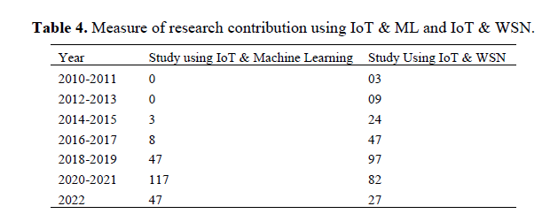

Figure 4 shows the research trends in two main categories: SEM using IoT & ML techniques and

IoT & WSN techniques. The trend line suggests that the SEM has yet to be implemented and studied

widely on machine learning or other approaches for training and subsequent classification or Prediction.

As reported, however, there has been an increase in research each year, but more impact of IoT and

Machine Learning in recent years can be seen in Figure 5.

The discussion and analysis above allow us to identify strategies for improving environmental

monitoring methods and tools. More powerful, robust, and innovative ways would benefit everyone. The

above discussion and analysis lead us to recommend the following:

1) There should be a framework for machine learning that needs to develop.

2) Irrespective of the purposes of using the SEM, a robust set of classification, forecasting models

& Predictions should be designed to operate any data.

3) Because most of the research has failed using de-noising data & their pre-processing, suitable

de-noising methods must be implemented.

4) To deal with big data issues involved in a few significant studies, data deduplication approaches

and methods are needed.

5) Government-level involvement from global and local perspectives is required for developing any

nation and city. As Smart Environment plays a crucial role in achieving sustainable goals, the rural areas

are kept behind most of the time, so it is challenging to set up the necessary infrastructure for IoT, WSN,

and other sensors.

6) When it comes to implementing sensors, ensure the data from them is compatible with all

acquisition and analysis systems to avoid interoperability issues.

**Conclusion and future scope:-**

In this paper, the author extensively reviews research studies on various environmental monitoring

systems used for different purposes. The analysis and discussion of the review suggest vital

recommendations for improving these systems. Research on deep learning, handling big data, and using

consistent classification approaches has led to a realization of the need for extensive research in these

areas. We have focused on water, air quality monitoring and intelligent waste management systems that

can deal with environmental challenges. The significant challenges in implementing smart sensors,

artificial intelligence (AI), and wireless sensor networks (WSNs) need to be addressed for sustainable

growth through Smart Environmental Monitoring (SEM). Participation by environmental organizations,

regulatory bodies, and general awareness would strengthen SEM efforts. Pre-processing techniques can

be used to improve the quality of sensory data. These techniques include filtering and signal processing,

which makes the data more suitable for tasks associated with SEM. The future scope of the work aims to study other environmental factors such as flexible sensing, energy harvesting sensing, marine pollution,

sound pollution, etc.